

**MEDICAL CENSORSHIP**

The media lies about an expert consensus supporting COVID vaccination. Many physicians and health experts fiercely oppose the COVID vaccines, but their voices are silenced. *Reporting of adverse reactions and deaths is obstructed.* Doctors4COVIDethics.org is a large international group of experts fighting these dangerous injections. They, too, are muzzled. People injured by the vax are also silenced.

**LOW EFFICACY**

COVID cases & deaths have shot up around the world following the roll-out. Israeli stats show that fully vaccinated people get COVID, including hospitalization and death, at the same rate as the unvaccinated.

**GENE THERAPY, NOT VACCINES**

COVID “vaccines” are unlike any other vaccines ever developed. All of them impart a strand of genetic code into your cells; essentially instructions for your body to make spike proteins. The media lies about them modifying your genes.

**CATASTROPHIC SAFETY RECORD**

*Developed since the 1980s, mRNA and DNA vaccines have a terrible safety record. They have never passed human trials. Often, most of the animals in animal trials have died.*

**LACK OF APPROVAL**

The shots have emergency use authorization, not full approval. The media reported that Pfizer’s vax got FDA-approved in Aug 2021, but it was actually a BioNTech product that was approved – one which is not set to be on the market for years.

**COMMON SEVERE SIDE EFFECTS**

The shots have a high rate of severe side effects, including blood clots (and consequently strokes & heart attacks), bleeding, cancer growth, neurological disease, paralysis, and myocarditis. One study found 62% of vaccinees had blood clots. From skirsch.com/covid/refuse.pdf: Many studies have estimated 1-2 deaths per 2,000 within 30 days. U.S. studies have est. 150,000 deaths as of Aug ‘21.

Vaccine adverse reactions are buried. Reported statistics are fraudulent.

Only 2 in a million children die from COVID. The shots are much more likely to kill them or cause long-term injury.

**MEDICATION: THE ALTERNATIVE TO VACCINES**

Over a dozen safe medications have a large evidence base of effectiveness for COVID. Early treatment reduces hospitalization and deaths by 85% (on average, 99% with some protocols) but the feds are keeping them from us so they can justify universal vaccination.

***Natural Immunity is Superior to Vaccine-Induced Immunity***

At least a quarter of people cannot get COVID due to exposure to common (cold) coronaviruses. After a SARS-CoV-2 infection, one cannot get sick from it again. The “re-infections” you read about are positive PCR test results, sometimes involving symptoms. They are not multiple illnesses from SARS-CoV-2.

**DURABILITY**

While antibodies wear off about 3 months after infection, your immunity system continues to protect you from another illness from SARS-CoV-2 with T-cells. People who had SARS in 2003, in fact, cannot get sick from SARS-CoV-2, suggesting permanent post-infection immunity following COVID.

**COVID TESTS ARE FRAUDULENT**

The standard diagnostic for COVID, PCR tests, have an accuracy of around 10%. Almost all positive results are false. This is deliberate. The government is inflating COVID cases and deaths to make it seem like there is an actual pandemic for which vaccination is warranted.

**VACCINE-ENHANCED DISEASE**

Aka antibody-dependent enhancement (ADE) or pathogenic priming, it refers to the paradoxical effect of a vaccine increasing the risk or severity of an infectious disease. Scientists are deeply concerned about it with COVID vaccines, some predicting permanent injury to the immune system and increased susceptibility to COVID. It takes a few months to a few years to develop, and the risk increases with every shot.

COVID-19 is less fatal than the flu for people under 70. Across all ages, the death rate of untreated COVID is only 0.15%. That falls to near zero with early treatment.

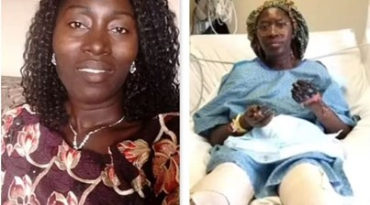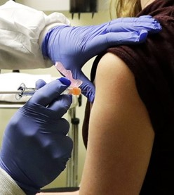

**COVID Vaccines**

Critical Info on the Experimental Gene Therapy

**THE JABS MAKE US SICK**

~80% of people get systemic side effects from COVID vaccines. Days of sickness following injection is the norm and the government wants you to get multiple shots per year. By contrast, less than 5% of people get sick from SARS-CoV-2 in a 12-month period. Even at 100% effectiveness, they would cause much more illness than they prevented.

**VACCINE PASSPORTS ARE PERSECUTION**

People who wisely avoid the harmful shots are being persecuted, villainized, bullied, and denied basic rights such as the right to work or buy food. The passport system hurts vaccinated people, as well. It gives government total control over your life and shuts you out of society if you don’t get another shot every few months.

Above: U.S. woman loses limbs to COVID vaccine.

.

**endlockdowns.org**

Protect yourself. Protect your community.



endlockdowns.org

Robin Monotti Channel

t.me/robinmg

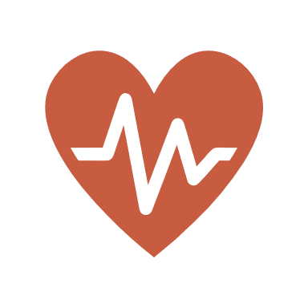

Doctors for COVID Ethics

doctors4covidethics.org

**UNTESTED**

**UNAPPROVED**

**UNNECESSARY**

**UNSAFE**

*No medical reason exists for the shots*.