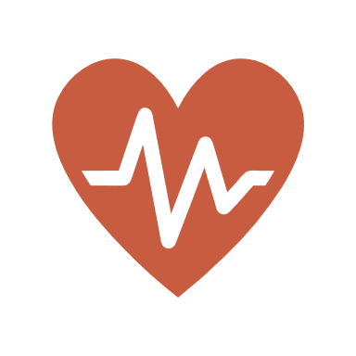

**endlockdowns.org**

***Do not get any more COVID shots. Do not comply with vaccine passports even if you are vaccinated. Do not follow the pandemic restrictions. Demand in-person, mask-free classes from your child’s school and its teachers’ union. Be vocal that you are against the restrictions. These are crimes against humanity being waged against us. Our families deserve better.***

**endlockdowns.org**

Doctors for COVID Ethics

doctors4covidethics.org

Robin Monotti Channel

t.me/robinmg

endlockdowns.org

**FURTHER INFORMATION**

**CRITICAL INFORMATION ON THE PANDEMIC RESPONSE**

**GET WRITING**

Write your state and federal representatives, employer, school, union, and any group following COVID ‘restrictions’ to demand that your rights be respected.

**GET WALKING**

Hang out with your friends, work from the office, go to protests, patron pro-freedom businesses only, hand out this brochure. Through our collective behavior, we will take back our lives.

**THE PANDEMIC RESPONSE IS CRIMINAL AND MUST BE OPPOSED URGENTLY.**

**CRIMINAL DENIAL OF HEALTHCARE**

Governments are withholding healthcare supposedly for the rush of COVID patients that has never come. Hospitals are not full like we are told. In fact, the entire healthcare system has largely been abandoned, resulting in increased illness and unnecessary deaths. This is inexcusable and criminal.

***For people under 70, SARS-CoV-2 is less fatal than the flu. Across all ages, the untreated fatality rate is 0.15%. There are meds which reduce fatality by 85%, but we are being denied them.***

**UNPRECEDENTED WEALTH TRANSFER**

*From April 2020 to April 2021, billionaires have witnessed their personal wealth soar by an incomprehensible $5 trillion. Meanwhile, the working class has taken a hit of $3.7 trillion in lost wages as of Jan. 2021. Lockdowns are disaster capitalism in the extreme. Small businesses fail and market share flows to multinational corporations.*

**LOCKDOWNS ONLY DO HARM**

Restrictions which limit human interaction cause severe suffering on par with an acute disease. 25% of people have entered a mental health crisis. Moreover, they reduce life expectancy by many years. They were absent from pandemic plans around the world when they began.

**ASYMPTOMATIC SPREAD MYTH**

All restrictions are based on the premise that you can spread COVID while not experiencing symptoms. Contrary to what we are told, it is quite rare for that to happen. That is why regions with stricter restrictions have no less coronavirus contagion.

THE PANDEMIC RESPONSE IS ROOTED IN FRAUD. YOUR GOVERNMENT IS NOT ACTING IN YOUR INTEREST.

**NATURAL IMMUNITY IS SUPERIOR**

*There is ample evidence that natural immunity to SARS-CoV-2, whether from an infection or prior exposure to a similar virus, is permanent and 100% protective. COVID vaccination, paradoxically, increases both cases and deaths from COVID.*

The standard COVID diagnostic, PCR tests, are highly inaccurate. They have a false positive rate in the order of 90% and cannot distinguish SARS-CoV-2 from the flu. The test is used to generate the panic necessary for people to surrender their rights.

**RESTRICTIONS DON’T WORK**

*The graph above from pandata.org shows no correlation between stringency of pandemic restrictions and COVID deaths. Lockdowns, social distancing, and masks serve no purpose but to make us feel like we are in a real pandemic.*

***Not all experts advocate for lockdowns or COVID vaccines. Many scientists and doctors oppose them, but intense censorship and intimidation keeps their message from being heard. Please see doctors4covidethics.org***

**23%**

**9%**

**68%**

**COVID VACCINES ARE UNSAFE**

Gov & media lie about virtually everything regarding the vaccines. Let’s set the record straight: They are not properly tested. They alter your genes. They may permanently damage your immune system, rendering you helpless to future exposure to pathogens. They carry very high risks of blood clotting and neurodegenerative disease. Long-term risks are high, but transparency is absent.

**LOW FATALITY OF COVID-19**